TIMS3311
Critical reflection a2
Isabella Galt
S4801762
Critical Reflection Word Count: 1559
Diary Entries: 1351

Critical Reflection

1. Overall WIL Experience

Personal lessons
My WIL experience with Eclipse, a biotechnology start-up developing lactoferrin for cosmetic applications has been a deeply practical and personal journey. Working across weekly meetings with Siobhan, class collaboration sessions, and individual research time, I’ve come to understand that innovation rarely follows a fixed path. Instead, it demands adaptability, curiosity, and reflection.

One of the most significant insights I learned about myself was that I perform best when working in conditions of uncertainty. Initially, I found the project’s open-ended structure challenging there were no predefined steps, clear guidelines, or obvious solutions but I soon realised that uncertainty pushes me to think creatively and take initiative. However, over time, I grew more comfortable operating within uncertainty. The persistant nature of our work, from initial store observations, interview questions, surveys to empathy mapping, taught me to trust the process and lean on frameworks such as Effectuation, which emphasises acting with the means available and co-creating outcomes through experimentation (Sarasvathy, 2001).

A major highlight was seeing our research evolve through each stage. During empathy mapping, I realised how rewarding it was to turn fragmented insights from interviews and surveys into clear behavioural patterns. It showed me how integral empathy and synthesis are to innovation. On the other hand, time management and aligning team schedules were difficult. Coordinating tasks between weekly meetings, lectures, and independent work often created tension. I learned to navigate these moments by setting smaller, achievable milestones and applying Design Thinking’s iterative “empathise-define-test” process (Liedtka & Ogilvie, 2011) to prioritise progress over perfection.

Another challenge was refining communication, translating large amounts of data into concise visuals and presentations. I learned that simplicity and clarity often carry more impact than complexity. In hindsight, if I could redo the WIL to the very start, I would focus more on measurable validation criteria early on. This would have given our team stronger quantitative evidence to complement the qualitative insights we gathered from interviews and MVP testing. Ultimately, this experience has built my confidence in navigating uncertainty, collaborating under pressure, and approaching entrepreneurship as a learning process grounded in reflection and adaptability.

Networks established
Throughout the placement, I developed valuable professional and interpersonal networks that extended well beyond my immediate team. Within our Eclipse group, collaboration became a genuine strength, we learned to draw on each other’s capabilities, whether it was data interpretation, creative design, or interview facilitation. These relationships built trust and accountability, mirroring the Effectuation principle of the “crazy quilt,” where partnerships form the foundation for co-creating new ventures (Sarasvathy, 2001).

Externally, our weekly discussions with Siobhan provided direct insight into the entrepreneurial ecosystem. Her experience as a founder exposed me to the realities of managing uncertainty, investor relationships, and product-market alignment. Interactions with store staff, beauty professionals, and potential customers during our validation stages also broadened my understanding of stakeholder engagement. These connections were not just transactional, they offered perspective, mentorship, and professional confidence that I will carry forward into future innovation and leadership contexts.

2. New Knowledge, Insights, and Skills

Key learnings
Before beginning my WIL placement with Eclipse, I had a theoretical understanding of innovation from previous coursework but limited experience applying entrepreneurial methodologies in a real start-up. Over the course of the placement, I developed a grounded understanding of three frameworks that now shape how I approach creative problem-solving: Design Thinking, Lean Startup, and Effectuation. Each moved from abstract theory to a practical tool for navigating uncertainty, enabling me to test, learn, and iterate with purpose.

The Design Thinking framework (Liedtka & Ogilvie, 2011) reshaped how I understand empathy - not as a soft skill but as a structured method for uncovering consumer insight. Liedtka and Ogilvie describe empathy as “seeing the world through your customer’s eyes,” allowing innovators to detect unmet needs that may not be directly expressed. This approach became central to me and my groups early work at Eclipse. Using empathy mapping, our team analysed what participants said, did, thought, and felt across three segments of female consumers, male consumers, and beauty professionals to reveal the emotional and practical factors driving skincare decisions.

Conducting store observations at Mecca, Sephora, and Chemist Warehouse before writing interview questions embodied the empathise and define stages of Design Thinking. Observing shoppers linger over “gentle” or “science-backed” products revealed that consumer trust and brand familiarity mattered as much as function. As (Liedtka & Ogilvie, 2011) notes, design thinkers focus on “observing behaviour and context, not just words.” This insight reframed our problem from “What can lactoferrin do?” to “How can we build trust in a new skincare ingredient?” anchoring our research in emotional understanding rather than technical performance.

The Lean Startup methodology (Ries, 2011) then introduced a disciplined way to validate what we observed. Ries defines entrepreneurship as “a process of learning what customers really want,” achieved through small, rapid experiments. Applying his build-measure-learn cycle, we built basic yet effective MVPs survey visuals testing consumer preference for serums, moisturisers, or sunscreen to be able to test which product would be most successful infused with lactoferrin; then measured responses through ranked-choice questions and open-ended feedback. We learned that “science-backed” and “natural” were the most resonant propositions, guiding our next MVP iteration.

Each experiment reinforced that progress depends not on execution speed but on learning efficiency. When some respondents were unfamiliar with the term lactoferrin, we simplified our language and re-tested using “fermented protein complex.” Ries’s (2011) principle that MVPs “maximise learning per unit of time” became our benchmark. This iterative approach taught me to prioritise testing assumptions over perfecting concepts, a shift from planning to active discovery that changed how I now interpret data and consumer behaviour.

The Effectuation framework (Sarasvathy, 2001) and (Sarasvathy, 2022) completed this learning by reframing how I think about uncertainty. Sarasvathy argues that entrepreneurs “control what they can rather than predict what they cannot” (Sarasvathy, 2001), working with available means of who they are, what they know, and whom they know. This mindset perfectly captured our situation with Eclipse, where resources were limited, outcomes kept shifting, and the path forward uncertain. We applied the affordable loss principle by investing only the time and effort necessary to gain useful insights from MVP tests, ensuring that failure remained a source of learning, not risk.

The crazy quilt principle of forming partnerships with committed collaborators was evident in our teamwork and engagement with Siobhan, Eclipse’s founder, and industry professionals. Their input shaped how we positioned lactoferrin in the skincare market. As (Sarasvathy, 2022) observes, “entrepreneurship is a process of co-creation,” and our collaboration reflected this shared agency. Equally, the lemonade principle, of turning surprises into opportunities proved transformative. When interviews and surveys revealed limited male engagement with skincare, we reframed it as strategic insight, focusing instead on female consumers and professionals as the key consumer entry markets which then formed our decisions of finding suitable brands that will be suitable for this market. This flexibility embodied Effectual logic by adapting to change rather than resisting it.

Together, these frameworks created a layered methodology for innovation. Design Thinking grounded me and the group in empathy and user observation; Lean Startup provided structure for iterative testing; and Effectuation fostered adaptability when outcomes were unpredictable. Their intersection was clearest during MVP testing: we empathised to select compelling imagery (Design Thinking), tested and refined propositions through real-time feedback (Lean Startup), and adjusted scope based on feasible resources (Effectuation).

The Future
This WIL experience has had a significant impact on how I see my career in marketing. Before working with Eclipse, I viewed marketing primarily through the lens of communication and branding. Now, I understand it as a dynamic process of experimentation, empathy, and value creation concepts deeply rooted in entrepreneurship. The Lean Startup cycle of build-measure-learn (Ries, 2011) has reshaped how I approach campaign design. Rather than aiming for the perfect strategy from the start, I now focus on testing ideas rapidly, analysing feedback, and pivoting when needed.

The Design Thinking process (Liedtka & Ogilvie, 2011) has also influenced how I approach consumer insight. In future marketing roles, I’ll use empathy mapping to uncover deeper motivations behind consumer choices and design creative strategies that respond to those needs. Meanwhile, Effectuation (Sarasvathy, 2001) has taught me to think resourcefully, leveraging available networks and opportunities to co-create with stakeholders rather than waiting for ideal conditions.

More broadly, I now see entrepreneurship not only as creating ventures but as a transferable approach to leadership, one that values feedback, reflection, and co-creation. This WIL experience has strengthened my interest in roles that bridge innovation and education, where human centred design and agile experimentation can drive lasting impact.

Course feedback
What I valued most in this WIL program was its authenticity and independence. Working directly with a real start up like Eclipse required applying entrepreneurial frameworks: Design Thinking, Lean Startup, and Effectuation, in a practical and often unpredictable context. The combination of guided structure and self-direction mirrored the reality of innovation work, teaching me how to manage uncertainty and adapt through experimentation.

For improvement, my first suggestion would be to include earlier MVP guidance, providing clearer examples or templates for hypothesis testing and validation. Second, I believe weekly online check-ins should be made mandatory rather than optional. The opportunity to join live sessions and receive immediate feedback was valuable for maintaining momentum and refining direction. Lastly, I recommend strengthening post WIL integration, linking final project outcomes to employability resources or digital portfolios to help students better translate their learning into professional growth.

Reflective Diary Entries

Diary Entry 1
Topic: Beginning our external validation through market observation

After presenting our initial pitch for Eclipse, we’ve now started our external validation phase to better understand the skincare market for lactoferrin. As a team, we’ve agreed that the best place to start is with real-world observation to see who’s buying skincare, what they’re choosing, and why. Our goal right now is to gain genuine, firsthand insight into consumer behaviour before moving into interviews.

We’ve spent this week visiting Mecca, Sephora, and Chemist Warehouse to observe shoppers, product displays, and brand engagement. It’s been fascinating to watch how people interact with different shelves and price points. Moisturisers and cleansers clearly dominate. In Chemist Warehouse, Cetaphil, CeraVe, and La Roche-Posay are everywhere - affordable, dermatologist-backed brands that people seem to trust. In Mecca, Dermalogica and Drunk Elephant draw the most attention, while Sephora shoppers seem especially drawn to The Ordinary and Tatcha, the Korean-inspired skincare brand. I’ve noticed that younger customers lean toward influencer driven, trendy brands, while older shoppers gravitate to science-backed and premium products. Interestingly, there are far more male shoppers in Chemist Warehouse than in the higher-end stores.

Seeing this firsthand really brings Lean Startup’s validated learning principle to life, testing assumptions through observation rather than theory. It also feels like Design Thinking’s Empathise stage in action. I’m starting to see how important it is to understand who we’re designing for before defining what to create.

These early insights are already shaping our direction. They’re showing me that lactoferrin’s success won’t just depend on its science, it’ll depend on consumer trust, positioning, and how seamlessly it fits into existing routines. Right now, observation feels like the most powerful learning tool we have.

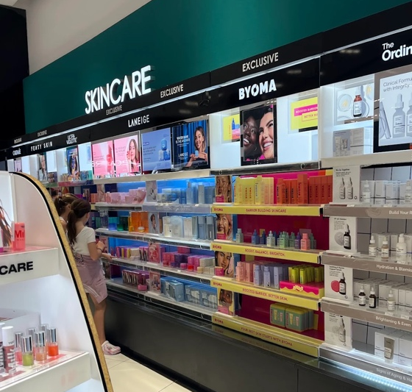
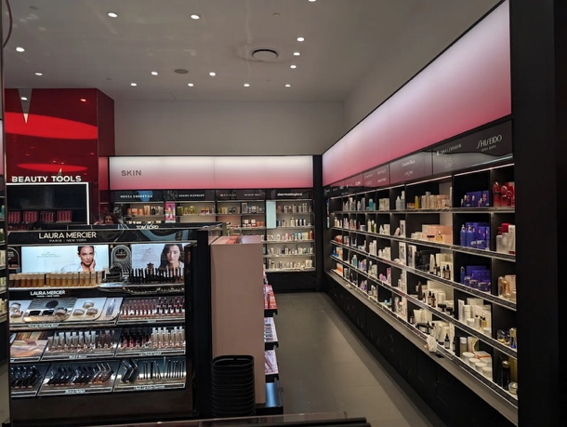

Figure 1 – Mecca Store
Figure 1 – Sephora Store

Diary Entry 2
Topic: Designing and refining our interview process

After completing our store observations, our next step in the external validation phase was to design interviews to test our early insights about the skincare market for Eclipse’s lactoferrin. Our team decided to interview a broad mix of females, males, and beauty retail professionals to ensure a range of perspectives across demographics and purchasing behaviours. We also aimed for diversity in age, recognising that attitudes toward skincare and willingness to pay often shift with life stage and income.

While writing our first set of questions, I noticed that we were getting too specific too quickly. We kept circling back to what we thought was interesting about lactoferrin instead of leaving room for the customer to guide us. We’ve since shifted direction and broadened our questions to focus on past behaviour - asking things like when participants last tried a new skincare ingredient, what made them trust it, how they researched it, and what convinced them to buy. Focusing on real experiences rather than hypotheticals feels much more valuable, because past behaviour usually predicts future choices.

This process really reminds me of the Lean Startup cycle: build, measure, learn and the Design Thinking stages of Empathise and Define. It’s helping me see that we’re not here to prove our ideas right but to listen, observe, and adapt.

Right now, I’m realising that effective validation comes from curiosity, not confirmation. These open, behaviour-based questions are already giving us richer insights into trust, buying triggers, and ingredient perceptions, all the things that will eventually help Eclipse build a product people genuinely want.

Diary Entry 3
Topic: Conducting interviews and uncovering consumer patterns

We’re now deep in the external validation phase, and today we’ve started running our customer interviews to test our early assumptions and guide Eclipse’s potential minimum viable product (MVP). Our team has organised interviews with a mix of female and male participants from different age groups, along with one beauty-retail professional, so we can capture a broad range of skincare routines, spending habits, and ingredient awareness.

One of our key questions is, “When it comes to skincare, what products do you prefer and why?” This is helping us see where lactoferrin could realistically fit into daily routines. So far, almost every participant has mentioned moisturisers, cleansers, serums, and sunscreens as their most essential products. It’s interesting that, regardless of age, those three keep repeating - they feel like clear MVP categories worth testing first.

As we move through the interviews, I’m noticing a pattern. Female participants give longer, more detailed answers - talking about ingredient science, texture, and brand trust - while male participants keep things brief, focusing on convenience or just using whatever’s available. It’s making us question whether a unisex approach would truly work for a first launch.

Running these interviews feels like putting Lean Startup’s validated-learning loop into action: gathering evidence, adjusting direction, and refining hypotheses. It also mirrors Design Thinking’s Define stage, where real user feedback sharpens understanding. Personally, I’m learning to hold back my own assumptions and let patterns speak for themselves.

Right now, it feels like a breakthrough - we’re finally seeing what real consumers value. Understanding these differences is giving us the clarity we need to define who Eclipse should focus on first and what product type makes the strongest starting point.

Diary Entry 4
Topic: Developing and distributing MVP surveys

We’ve just finished our interviews, and now we’re designing Eclipse’s first MVP surveys to test our early product ideas for lactoferrin in cosmetics. Our focus right now is to figure out which skincare format moisturiser, serum, cleanser or sunscreen has the most potential and what kind of messaging connects best with people: science-backed efficacy, natural purity, or luxury lifestyle. Using Lean Startup thinking, we want to validate these ideas quickly and affordably through SurveyMonkey, simple landing-page mock-ups, and QR code flyers.

At first, our questions were far too detailed more like a full market research study than an MVP test. We realised we needed something visual, concise, and easy to respond to. Now we’re building surveys with 20–30-word product descriptions paired with product mock-ups, asking people to rank their preferences and tell us why. This “show-don’t-tell” approach feels much more realistic, it’s like stepping into Design Thinking’s Prototype stage, turning ideas into something people can react to instead of imagining.

To reach real consumers, we’re sharing the survey across Facebook skincare communities, beauty group chats, and flyers in Mecca, Sephora, and Chemist Warehouse, bus stops with QR codes that link straight to our form (Figure 4 below). We’re already noticing how much more engaged people are when they can see something instead of just reading about it.

Right now, I’m learning how powerful effectual thinking can be using what we have and improving as we go. People respond best to visuals, simplicity, and clear choices. These surveys are helping us move from abstract ideas to tangible validation, testing not just what consumers say, but how they react. It feels like a real turning point in shaping Eclipse’s first viable product direction.
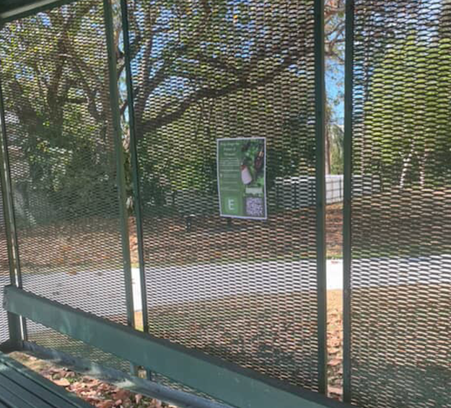
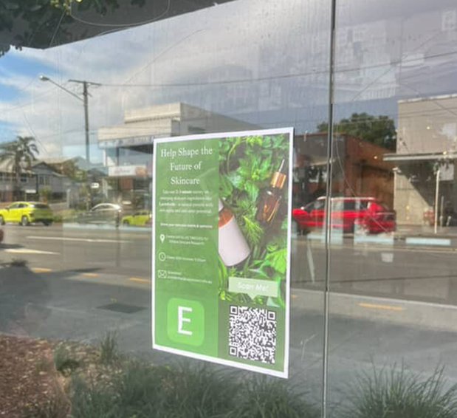

Figure 4 – Survey Distribution

Diary Entry 5
Topic: Empathy mapping and analysing user insights

We’re now at the stage of pulling everything together. With all our interview and MVP survey data in front of us, our team is working through the empathy mapping process to turn raw feedback into meaningful insights for Eclipse’s final Business Model Canvas (BMC). We’ve decided to create two separate empathy maps, one based on our interview findings and another on the survey results, so we can see whether people’s stated attitudes match their actual choices when responding to visuals and product mock-ups.

To make sense of the data, we’re grouping participants into female consumers, male consumers, and beauty professionals. For each, we’re mapping what they say, do, think, and feel about skincare and new ingredients like lactoferrin. The female group consistently mentions “trust,” “gentleness,” and “visible results,” showing how much they value credible science and reassurance. The male group focuses on practicality and convenience, seeing skincare as something that should “just work.” The beauty professionals provide a more technical view talking about ingredient credibility, irritation risk, and growing interest in “clean science.”

It’s been challenging but rewarding. Some insights align neatly, while others contradict each other, forcing us to dig deeper as a team. I can see how much sharper our thinking has become through these discussions.

Right now, this feels like Design Thinking’s Synthesis phase in action, organising scattered observations into something clear and usable. Creating these two empathy maps is giving us structure and direction, helping us define customer segments and value propositions that will guide Eclipse’s BMC and next stage of market validation.

References:
Liedtka, J., & Ogilvie, T. (2011). Designing for Growth: A Design Thinking Tool Kit for Managers (1st ed.). Columbia University Press. https://ebookcentral.proquest.com/lib/uql/detail.action?docID=908807

Osterwalder, A., Pigneur, Y., Bernarda, G., & Smith, A. (2014). Value Proposition Design : How to Create Products and Services Customers Want. (1st ed., Vol. 2). John Wiley & Sons. https://ebookcentral.proquest.com/lib/uql/detail.action?docID=1887760

Ries, E. (2011). THE LEAN STARTUP. https://ia800509.us.archive.org/7/items/TheLeanStartupErickRies/The%20Lean%20Startup%20-%20Erick%20Ries.pdf

Sarasvathy, S. D. (2001). Causation and Effectuation: Toward a Theoretical Shift from Economic Inevitability to Entrepreneurial Contingency. Academy of Management Review, 26(2), 243–243. https://doi.org/10.2307/259121

Sarasvathy, S. D. (2022). Effectuation. https://doi.org/10.4337/9781839102585

